Story Response - Maximum Story Drifts

Summary Description
This is story response output for a specified range of stories and a selected load case or load combination.

Input Data
Name | StoryResp4
Display Type | Max story drifts | Story Range | All Stories
Load Case | RS | Top Story | Story6
Output Type | Not Applicable | Bottom Story | Base

Plot
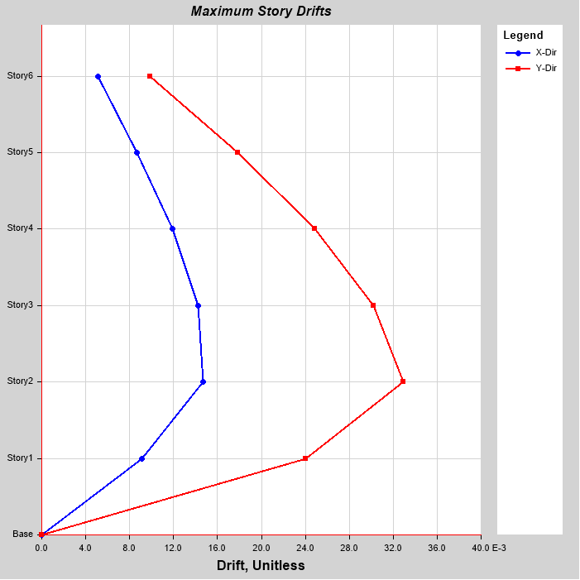

Tabulated Plot Coordinates
Story Response Values

Story | Elevation | Location | X-Dir | Y-Dir
 | m
Story6 | 18 | Top | 0.005103 | 0.009865
Story5 | 15 | Top | 0.008655 | 0.017841
Story4 | 12 | Top | 0.011881 | 0.024844
Story3 | 9 | Top | 0.0142 | 0.030226
Story2 | 6 | Top | 0.014667 | 0.032942
Story1 | 3 | Top | 0.009087 | 0.024057
Base | 0 | Top | 0 | 0

